Phase 6 – Project Testing
Script-Controlled ACL – Restrict Record Access Based on Field Value
1. READ ACL Testing
The EEE User was impersonated and the Student Records list was opened using:
u_institution_details.list
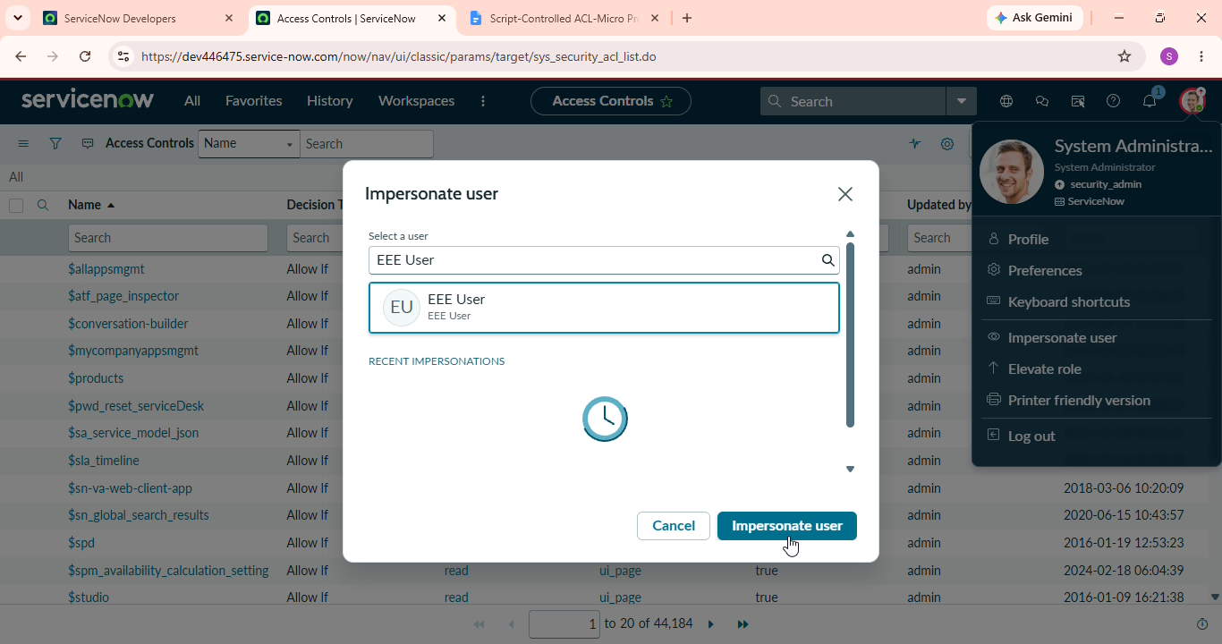
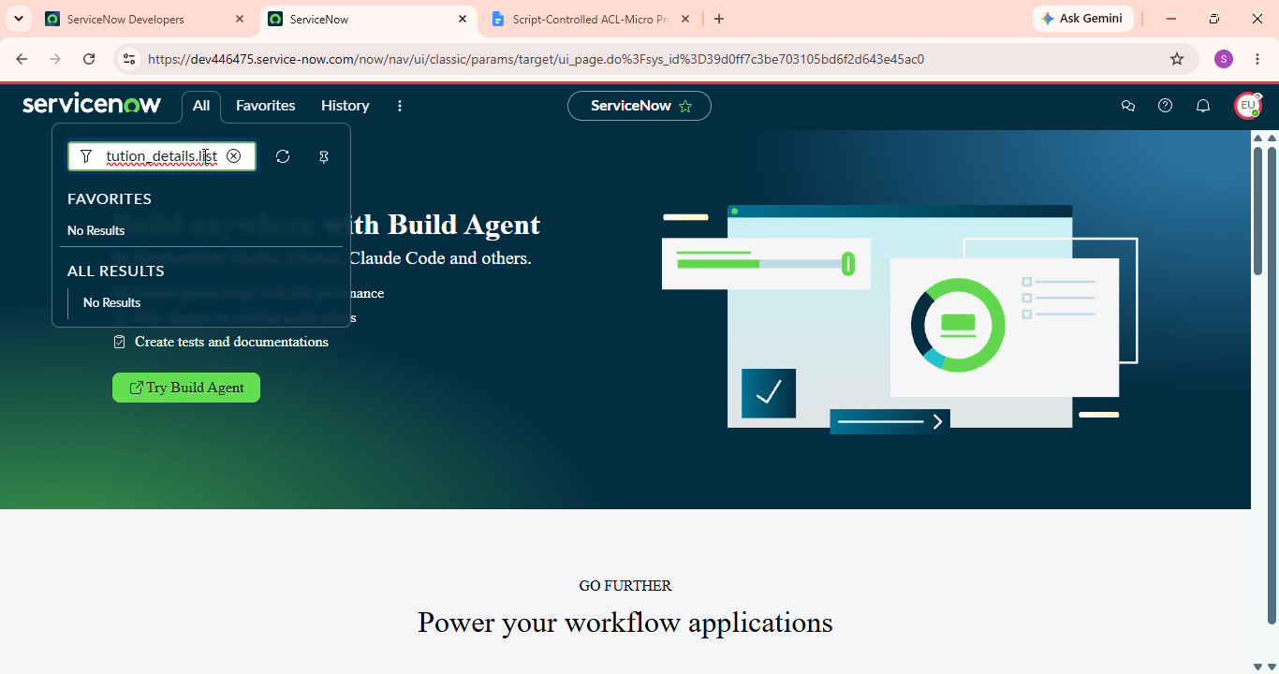

2. READ ACL Verification
The following results were verified:
- A user with the bb1 role can view EEE branch records.
- A user without the required role cannot view records.
- An administrator can view all records regardless of branch.
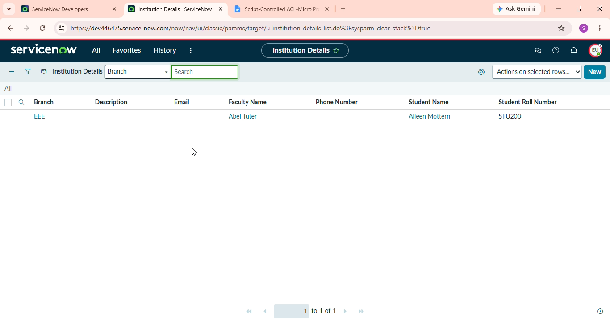

3. CREATE ACL Testing
The CREATE ACL was tested using a user with:
- bb1
- bb2
The user should be able to view EEE branch records and access the New button.
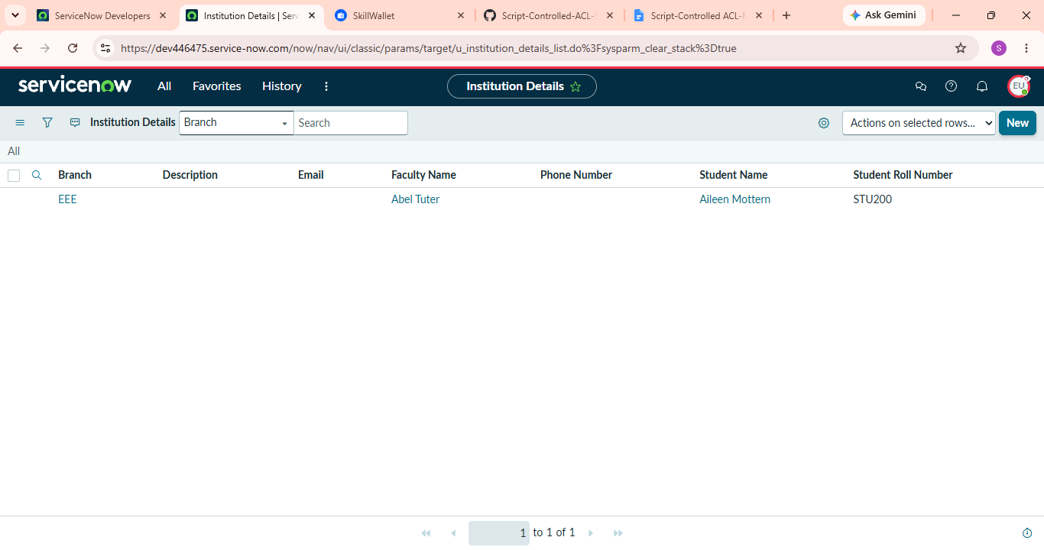
4. WRITE ACL Testing
The WRITE ACL was tested using a user with:
- bb1
- bb2
- bb3
The user should be able to view and edit EEE branch records along with the New button.
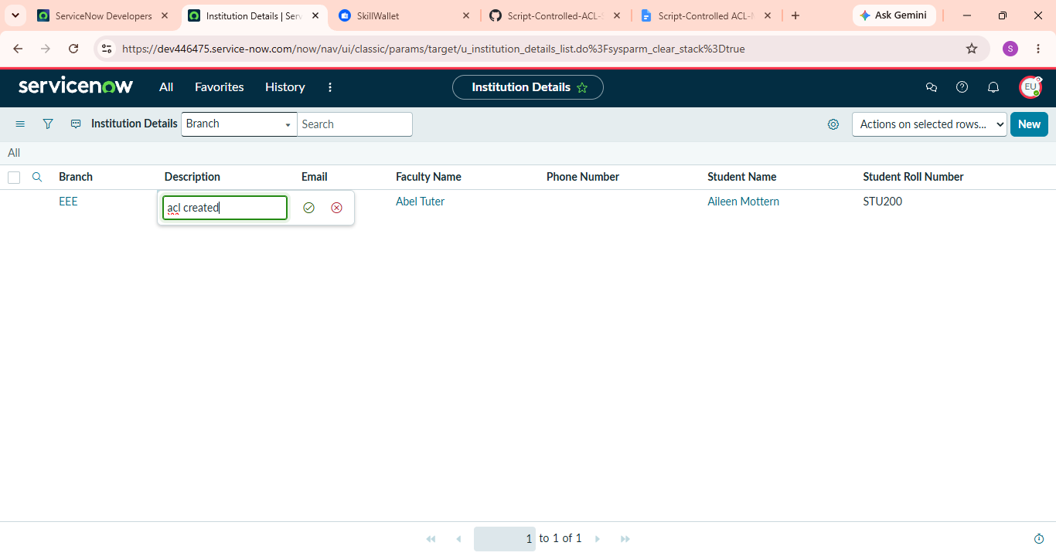

5. DELETE ACL Testing
The DELETE ACL was tested using a user with:
- bb1
- bb2
- bb3
- bb4
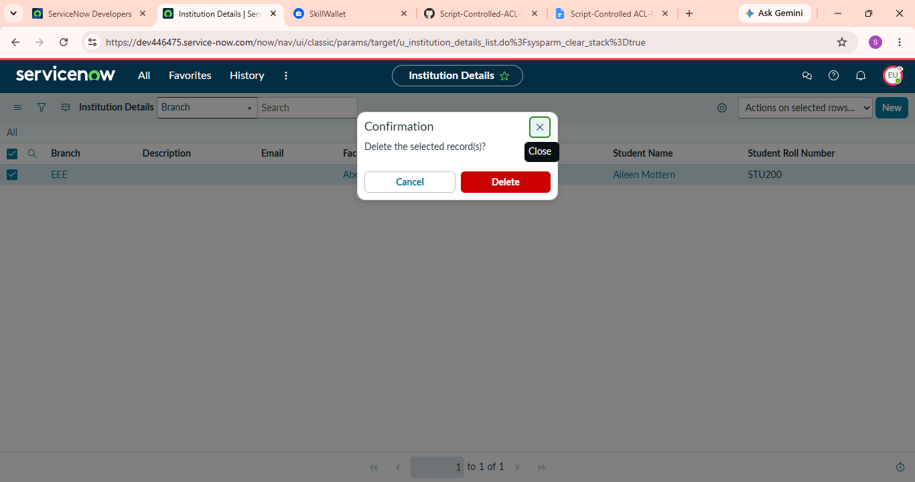
The user should be able to:
- View EEE records
- Create records
- Edit records
- Delete records
6. Admin Testing
The administrator was impersonated and the Student Records list was opened.
The administrator should be able to view all records regardless of the Branch value.
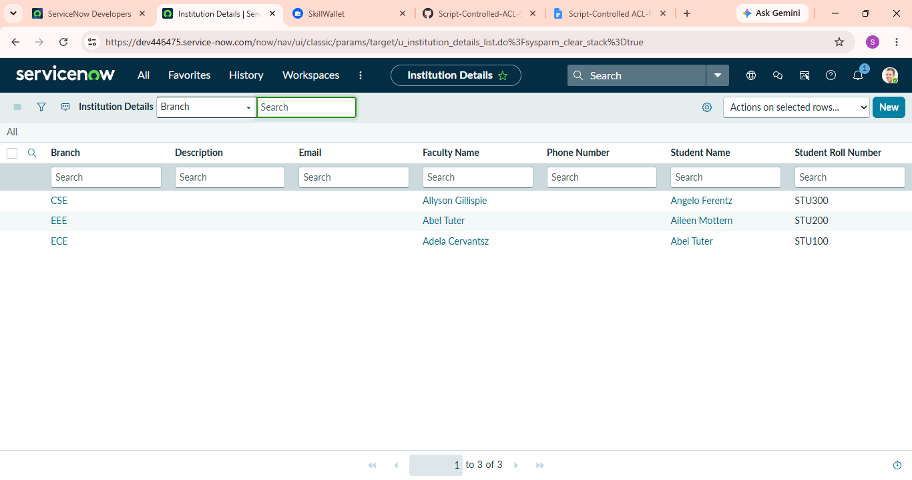
7. Testing Evidence
Screenshots should be added showing:
- EEE User impersonation
- EEE records
- Restricted access
- Admin access
- New button
- Edit access
- Delete access
8. Testing Result
The testing verifies the behaviour of the configured READ, CREATE, WRITE and DELETE ACLs.

